

FINAL PROJECT
End-to-End ML System Development

Course | : | DDM501.22 - AI in DevOps, DataOps, MLOps
Project topic | : | Predict Customer Satisfaction / Trust Toward AI in Online Shopping
Professor | : | Dr. Nguyen Doan Dong
Group | : | Group 4  - Do Doan Bac  - Nguyen Tuong Lam  - Do Huy Nam  - Do Thanh Vu

TABLE OF CONTENTS
1 PROBLEM DEFINITION & REQUIREMENTS 3
1.1 Business context 3
1.2 Problem statement 5
1.3 Stakeholders and users 6
1.4 User requirements and Use-cases 7
1.5 Success Metrics 10
1.6 Scope and constraints 12
2 SYSTEM DESIGN & ARCHITECTURE 13
2.1 High-Level system architecture 13
2.2 Component design 13
2.3 Data flow 18
2.4 Technology stack 18
2.5 Trade-off analysis 19
3 IMPLEMENTATION 23
3.1 ML Pipeline 23
3.2 Deployment 24
3.3 Monitoring 25
4 MONITORING 27
4.1 Prometheus 27
4.2 Grafana 28
5 TESTING & CI/CD 29
5.1 Unit tests 29
5.2 Integration tests 29
5.3 Data quality tests 29
5.4 CI/CD Pipeline 30
6 RESPONSIBLE AI 32
6.1 Fairness Analysis and Bias Detection 32
6.2 Model Explainability 32
6.3 Data privacy considerations 33
6.4 Ethical implications 33
7 DOCUMENTATION 35
7.1 README 35
7.2 API Documentation 36
8 CONCLUSION 36
9 REFERENCES 37

PROBLEM DEFINITION & REQUIREMENTS

Business context
In the context of the rapid growth of e-commerce (EC), technologies based on Artificial Intelligence (AI) such as chatbots, recommendation systems, virtual assistants, and automated question-answering tools are increasingly playing an important role in customer experience. Businesses are investing more in AI to optimize costs, increase response speed, and improve service quality. Specifically:
- 84% of e-commerce businesses are using AI in one form or another in their online operations [1].
- The AI market in e-commerce reached approximately USD 8.65 billion in 2025 and is projected to grow to USD 22.6 billion by 2032, demonstrating strong growth [2].
- More than 50% of e-commerce companies have integrated AI to enhance their business operations [3].
AI also significantly impacts operational efficiency and business performance:
- AI-driven personalization can increase conversion rates by 15–35% [4].
- AI chatbots can handle up to 80% of customer inquiries without human intervention [5]
- AI helps reduce stock-out situations and optimize inventory management, lowering shortages by 20–30% compared to traditional methods [6].
- AI reduces logistics costs by 5% to 20% through demand prediction and operational optimization [7].
- Approximately 62–67% of online shoppers expect a personalized shopping experience powered by AI [8].
AI is also changing consumer behavior trends:
- AI-influenced online sales worldwide increased from USD 199 billion to approximately USD 229 billion during the 2024–2025 holiday season [9].
- AI significantly increases online shopping traffic (for example, 805% growth in AI-driven traffic during Black Friday 2025 in the U.S.) [10].
- It is predicted that nearly 50% of online shoppers in the U.S. will use AI assistants by 2030, contributing an additional USD 115 billion to the e-commerce market [11].
Artificial Intelligence (AI) technologies are increasingly integrated into e-commerce platforms to enhance the online shopping experience. Examples include:

- Customer Behavior Personalization: AI analyzes purchase history, product views, and user interactions to recommend relevant products, thereby increasing conversion rates and average order value [12].
- Chatbots & Virtual Assistants: AI chatbots handle frequently asked questions, provide 24/7 customer support, and resolve up to 80% of basic requests, allowing human staff to focus on more complex tasks [13].
- Inventory and Supply Chain Management: AI predicts demand in real time, helping to: Reduce stock shortages by 20–30% [14]; Optimize inventory levels, reducing storage costs and preventing lost sales.
- Dynamic Pricing: AI analyzes supply-demand data, competitor pricing, and customer behavior to automatically adjust prices and maximize revenue.
- Fraud Detection: Machine Learning algorithms detect abnormal transaction patterns, reducing financial losses and fraud risks.
- Image and Voice Search: AI enables users to search for products using images or voice, improving the shopping experience and helping customers find suitable products more quickly [15].
- Customer Experience Management: AI analyzes customer sentiment and feedback from reviews and comments to: Measure customer satisfaction; Improve products and services; Develop more effective customer service strategies.
- AI-powered product recommendation systems: Systems that use artificial intelligence to analyze user behavior, preferences, and purchase history in order to recommend relevant products and improve customer engagement.
- Personalized product suggestions: Tailored product recommendations based on an individual user’s interests, browsing activity, and past purchases, providing a more relevant and customized shopping experience.
- AI chatbots for customer service: AI-driven chatbots that interact with customers in real time, answer common questions, and provide 24/7 support, improving response speed and service efficiency.
- Automated customer support systems: Systems that automate customer service processes such as request handling, ticket classification, and response generation, reducing manual workload and enhancing operational efficiency.
While these technologies aim to improve convenience and personalization, customer acceptance and trust toward AI systems remain critical factors determining their success.
Understanding how customers perceive AI systems and what factors influence their satisfaction is essential for businesses seeking to adopt AI-driven shopping experiences.
Companies need data-driven insights to answer questions such as:
- Which users trust AI recommendations?
- What factors influence customer satisfaction with AI systems?
- How does demographic background influence AI adoption?
This project proposes an ML-enabled system that predicts customer satisfaction or trust toward AI systems in online shopping environments.
The system enables companies to analyze customer perceptions and make informed decisions regarding AI adoption strategies.

Problem statement
However, not all customers are satisfied with AI-powered tools. Some users find AI convenient and fast, while others believe that AI lacks natural interaction, fails to resolve their issues, or creates frustration during communication.
E-commerce platforms therefore need to understand “what factors make customers satisfied or dissatisfied when interacting with AI systems” in order to improve these systems, optimize customer service costs, and retain users. Specifically, this helps businesses to:
- Understand the factors influencing customer satisfaction
- Optimize AI systems
- Personalize user experiences
- Reduce customer churn rates
- Increase customer retention rates
To address this need, a Machine Learning system is developed to predict customer satisfaction responses to AI interactions. The problem is formulated as a supervised classification problem, where the input features include:
The objective of this project is to design and implement a machine learning system capable of predicting customer satisfaction or trust toward AI-assisted online shopping experiences.
The system will analyze factors including:
- Demographic characteristics
- Online shopping behavior
- AI usage behavior
- Trust and perception toward ai systems
Using these inputs, the system predicts whether customers are likely to have high or low satisfaction toward AI-powered shopping features.

Stakeholders and users

Stakeholders
No | Group | Stakeholders | Responsibilities
1 | Business Users
1.1 |  | E-commerce Product Managers | Evaluate effectiveness of AI shopping features  Monitor customer satisfaction trends  Improve AI-based recommendation systems
1.2 |  | Customer Experience Team | Monitor customer trust in AI systems  Identify segments of dissatisfied users
1.3 |  | Marketing Analysts | Understand customer attitudes toward AI  Design targeted marketing strategies
1.4 |  | Customer Support Agents | Customer support teams can use the system insights to understand customer dissatisfaction trends and improve service quality.
2 | Technical Users
2.1 |  | Data Engineers | Maintain data ingestion pipelines  Ensure data quality
2.2 |  | ML Engineers | Train and evaluate machine learning models  Track experiments using Mlflow
2.3 |  | DevOps Engineers | Deploy and maintain system infrastructure  Monitor system performance
3 | End Users
3.1 |  | Online Shoppers | Online Shoppers  Online shoppers interact with AI-powered shopping systems such as recommendation engines and chatbots.
Table 1: List of stakeholders

Users (Personas)
Users are individuals or teams who interact directly with the system and use its outputs to support their daily operations.
No | User | System interaction
1 | Customer Service Managers | - Access satisfaction analytics dashboards  - Analyze prediction results
2 | Customer Experience Team | - Access satisfaction reports  - Investigate customer perception patterns
3 | Marketing Analysts | - Analyze satisfaction prediction insights  - Evaluate customer segmentation
Table 2: List of users

User requirements and Use-cases

User requirements
No | User requirement | System interaction
1 | Customer satisfaction prediction | - The system must be able to predict customer satisfaction or trust toward AI-powered online shopping systems based on user demographic characteristics, shopping behavior, and AI usage patterns.  - This capability allows businesses to understand customer attitudes toward AI technologies and improve AI-driven shopping experiences.
2 | Customer segmentation based on AI perception | - The system must be able to identify different groups of customers according to their trust and satisfaction toward AI technologies.  - This functionality helps organizations better understand customer attitudes toward AI systems and develop targeted strategies for different user segments.
3 | AI adoption analysis | - The system must provide analytical insights about which demographic groups are more likely to adopt AI-powered shopping tools.  - These insights help businesses understand patterns of AI adoption and identify potential barriers to AI acceptance.
Table 3: List of users

Use-cases
- Use-case 1 - Predict customer satisfaction toward AI systems
Actor: Marketing Analysts, Customer Service Managers
Description:
The user submits customer-related attributes such as demographic information, shopping behavior, and AI usage characteristics to the system.
The machine learning model processes the input data and predicts the expected level of satisfaction or trust toward AI-powered online shopping systems.
Example
Input:
Age: 25
Shopping frequency: weekly
AI recommendation usage: high
Trust in AI: medium
Output:
Predicted satisfaction level: High
Business Value
- Understand customer perception of AI services
- Improve AI-based recommendation systems
- Enhance customer experience
- Use-case 2 – Customer segmentation based on AI perception
Actor: Marketing analyst, Customer Experience Team
Description:
The system analyzes customer characteristics and AI perception data to group customers into segments based on their trust and satisfaction toward AI technologies.
Example segments may include:
- AI Enthusiasts
- Neutral Users
- AI Skeptical Users
Business Value
This segmentation enables companies to design targeted marketing strategies and personalized user experiences.
For example:
- Promoting AI-powered features to AI enthusiasts
- Providing additional explanations or human support to skeptical users
- Use-case 3 – AI adoption analysis
Actor: Marketing Analysts
Description:
The system analyzes customer demographic data and behavioral patterns to identify which groups of customers are more likely to adopt AI-powered shopping systems.
Example insights
- Younger users may trust AI recommendations more
- Users with higher online shopping frequency may rely more on AI tools
Business Value
These insights help companies:
- Improve AI product design
- Identify potential barriers to AI adoption
- Plan marketing and product strategies

Success Metrics

Business goals
The primary objective of the system is to understand and predict customer satisfaction and trust toward AI-powered features in online shopping platforms, such as recommendation systems and chatbots.
By leveraging prediction and segmentation, the system helps organizations improve AI adoption strategies and customer experience.
Business Goal | KPI | Target | Measurement Method
Improve understanding of customer satisfaction toward AI systems | Customer Satisfaction Insight Accuracy | ≥ 80% alignment with survey data | Compare model predictions with actual dataset labels
Identify customer segments based on AI perception | Segmentation Quality Score | Clearly separable segments | Clustering validation / distribution analysis
Increase effectiveness of AI-driven marketing strategies | Targeted Campaign Effectiveness | Improvement in engagement rate (≥ 10%) | A/B testing or simulated evaluation
Improve adoption of AI-powered features | AI Adoption Rate | Increase adoption by 10–15% | Analysis of AI usage behavior
Enhance personalization strategies | Recommendation Relevance Score | ≥ 20% improvement in relevance | User interaction analysis
Table 4: Business Goals and KPIs
These business metrics evaluate whether the system:
- Provides useful insights about customer behavior
- Supports decision-making in marketing and product design
- Helps organizations optimize ai adoption strategies

System goals
System goals define the technical performance and reliability of the deployed ML system.
These metrics ensure the system can operate effectively in a production environment.
Metric | Target | Measurement Method
System Availability (Uptime) | ≥ 99% | Monitoring logs and uptime tracking
Prediction API Latency | < 200 ms per request | API monitoring tools
Prediction Throughput | ≥ 1000 requests/minute | Load testing
Data Pipeline Reliability | ≥ 99% successful runs | Pipeline logs and error tracking
Model Deployment Frequency | At least 1 update/month | CI/CD logs
Monitoring Coverage | 100% services monitored | Prometheus metrics coverage
Table 5: System Goals and Metrics
These system-level metrics ensure that:
- the API is fast and responsive
- the system is stable and reliable
- the pipeline can handle real-world workloads

Model goals
Model goals evaluate the predictive performance of the machine learning model, which is responsible for predicting customer satisfaction levels.
Since this is a classification problem, standard classification metrics are used.
Metric | Formula | Target | Rationale
Accuracy | (TP + TN) / (TP + TN + FP + FN) | ≥ 85% | Measures overall correctness
Precision | TP / (TP + FP) | ≥ 80% | Ensures reliable positive predictions
Recall | TP / (TP + FN) | ≥ 80% | Captures most true satisfaction cases
F1-score | 2 × (Precision × Recall) / (Precision + Recall) | ≥ 0.80 | Balances precision and recall
ROC-AUC | Area under ROC curve | ≥ 0.85 | Measures class separability
Table 6: Model Goals and Metrics
Definition of Terms
- TP (True Positive): correctly predicted satisfied customers
- TN (True Negative): correctly predicted dissatisfied customers
- FP (False Positive): incorrectly predicted satisfied customers
- FN (False Negative): missed satisfied customers

Scope and constraints

Scope
The system includes:
- ML data pipeline
- Feature engineering
- Machine learning model training
- REST API deployment
- Monitoring infrastructure

Constraints
- Limited dataset size
- Limited computational resources
- Course project time limitations

SYSTEM DESIGN & ARCHITECTURE

High-Level system architecture
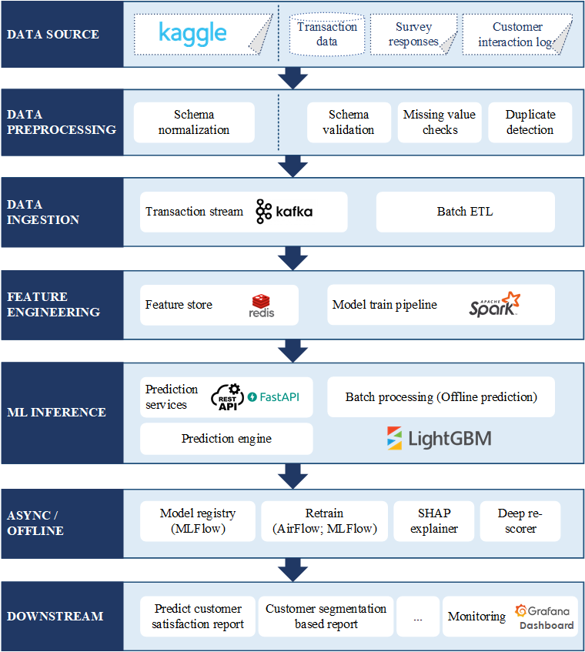
Figure 1: System architecture

Component design

Data Source layer
The system primarily utilizes a dataset obtained from Kaggle, specifically the Customer Satisfaction Response to AI Dataset. This dataset contains structured information about customer demographics, shopping behavior, AI usage behavior, and trust/perception toward AI systems.
For model development, the dataset is divided into three subsets:
- Training set: used to train the machine learning model
- Validation set: used for hyperparameter tuning and model selection
- Test set: used for final evaluation of model performance
This structured dataset serves as the main data source for building and evaluating the “Predict Customer Satisfaction Toward AI” system.
In addition to the Kaggle dataset, the system architecture is designed to support integration with multiple heterogeneous data sources in a real-world deployment scenario. These include:
- Transaction Data:
Administrative and behavioral data of customers, such as purchase history, shopping frequency, and product interactions.
- Survey Responses:
Structured data capturing customer perceptions, trust levels, and satisfaction toward AI-powered services.
- Customer Interaction Logs:
Logs generated from interactions with AI systems (e.g., chatbot usage, recommendation clicks), including explicit feedback such as satisfaction or dissatisfaction.
These data sources provide a comprehensive view of customer behavior and perception, enabling both accurate model training and meaningful business insights.

Data Preprocessing layer
For this project, the primary dataset obtained from Kaggle is relatively well-structured and clean. The dataset already follows a consistent schema and does not contain significant missing values or duplicates.
Therefore, preprocessing for the Kaggle dataset mainly focuses on Schema normalization:
- Transforming and aligning the raw Kaggle schema to match the internal model schema used in the system.
- This ensures consistency between training and inference pipelines.
However, in a real-world deployment scenario, the system is designed to handle heterogeneous and potentially noisy data sources. In such cases, a comprehensive preprocessing pipeline is required.
Before data is consumed by downstream components, it undergoes preprocessing to ensure data quality and consistency.
Key processes include:
- Schema Validation:
Ensures that incoming data conforms to predefined schemas and data types.
- Missing Value Checks:
Identifies and handles incomplete records using imputation or filtering strategies.
- Duplicate Detection:
Removes redundant records to prevent bias and data leakage in model training.
This layer guarantees that only clean, consistent, and reliable data is passed to the ingestion pipeline, thereby improving model performance and system robustness.

Data Ingestion layer
For this project, the system provides two flexible ways to ingest data from the Kaggle dataset, enabling both manual and automated workflows.
Option 1: Manual Data Ingestion
Users can manually provide the dataset by placing a compatible CSV file into the following directory:
data/raw/online_shopping_ai.csv
The system will automatically detect and use this file as the input for downstream processing, including preprocessing, feature engineering, and model training.
Option 2: Automated Data Ingestion from Kaggle
The system also supports automatic data ingestion from Kaggle using the default dataset:
pooriamst/online-shopping
In most cases, no additional configuration is required.
When the training process is triggered, the ingestion pipeline will:
- Download the dataset using kagglehub
- Automatically locate the first CSV file
- Copy it into:
data/raw/online_shopping_ai.csv
- Continue the ingestion and training pipeline
This approach simplifies data acquisition and ensures reproducibility of experiments.
In a production environment, the system is designed to support both real-time and batch data ingestion mechanisms:
- Transaction Stream (Kafka):
Real-time ingestion of customer interaction events, enabling near real-time analytics and predictions.
- Batch ETL:
Periodic ingestion of structured datasets (e.g., survey data), typically processed on a scheduled basis.
This hybrid ingestion strategy ensures flexibility in handling both streaming data and historical datasets, making the system adaptable to real-world MLOps scenarios

Feature Engineering layer
This layer transforms raw data into meaningful features for machine learning models.
Components include:
- Feature Store (Redis):
  - Stores precomputed features for fast retrieval during inference.
  - Enables consistency between training and serving environments.
- Model Training Pipeline (Spark Pipeline):
  - Performs large-scale feature transformation and preparation during offline training.
  - Supports scalable data processing for model development.
This layer plays a critical role in improving model performance and inference efficiency.

ML Inference layer
The ML Inference layer is responsible for generating predictions using trained models.
Key components include:
- Prediction Services (FastAPI / REST API):
Expose model prediction endpoints for real-time use by applications.
Available endpoints:
GET /api/v1/health
GET /api/v1/model/info
POST /api/v1/predict
POST /api/v1/predict/batch
GET /metrics
- Batch Processing (Offline Prediction):
Performs large-scale predictions on historical data for reporting and analytics.
- Prediction Engine:
Handles input processing, feature retrieval, and model execution.
- LightGBM Scorer:
The core prediction model that computes customer satisfaction scores based on input features.
This layer enables both real-time and batch prediction capabilities.

Async / Offline layer
This layer handles computationally intensive and non-real-time tasks.
Key components include:
- Model Registry (MLflow):
Stores trained models, tracks versions, and manages model lifecycle.
- Model Retraining (Airflow + MLflow):
Automates periodic retraining pipelines to keep models up-to-date.
- SHAP Explainer:
Provides interpretability by explaining feature contributions to model predictions.
- Deep Re-scorer:
Applies additional refinement to prediction results, potentially using more complex models.
This layer ensures continuous improvement and explainability of the ML system.

Downstream layer
The downstream layer consumes prediction outputs and transforms them into business value.
Key components include:
- Customer Satisfaction Reports:
Analytical reports summarizing customer satisfaction trends and AI perception.
- Monitoring (Grafana Dashboard):
Visualizes system metrics, model performance, and operational health using data collected from monitoring tools (e.g., Prometheus).
This layer enables:
- business decision-making
- performance monitoring
- strategic planning

Data flow
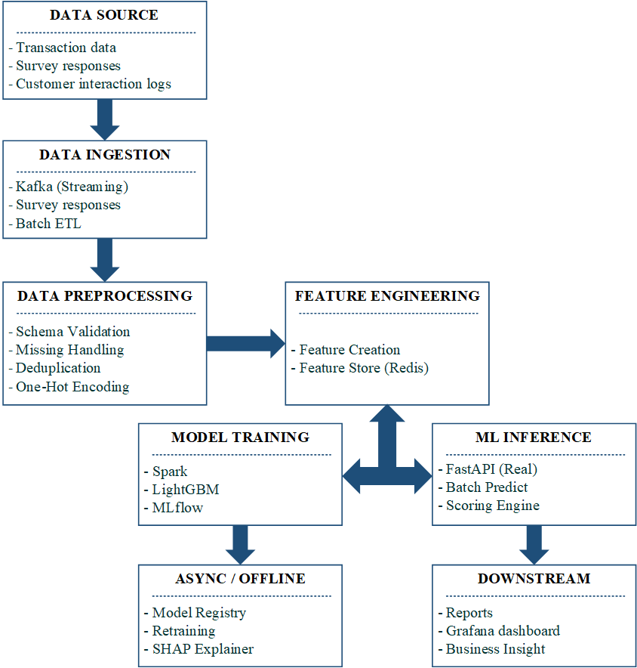
Figure 1: Data Flow

Technology stack
Layer | Technology
Data processing | Pandas
Machine learning | Scikit-learn
Experiment tracking | MLflow
API | FastAPI
Containerization | Docker
Orchestration | Docker Compose
Monitoring | Prometheus
Visualization | Grafana
CI/CD | GitHub Actions
Table 7: Technology stack

Trade-off analysis
In designing the Customer Satisfaction Prediction Toward AI in Online Shopping System, several important trade-offs must be carefully considered. In real-world MLOps systems, improving one aspect (e.g., accuracy or scalability) often leads to compromises in other aspects such as latency, cost, or system complexity. Therefore, a balanced design approach is required to ensure both technical efficiency and business value.

Accuracy and latency
One of the most critical trade-offs in this system is between prediction accuracy and response latency.
More advanced machine learning models such as LightGBM (Gradient Boosting) can capture complex relationships between customer demographics, shopping behavior, and AI perception. This leads to higher prediction accuracy when estimating customer satisfaction or trust toward AI systems.
However, these models are computationally more expensive compared to simpler models, which can increase inference time.
In contrast, simpler models such as Logistic Regression provide faster predictions but may fail to capture nonlinear relationships in behavioral data, leading to lower predictive performance.
In an online shopping context, latency is important when predictions are used in real-time applications (e.g., personalization or AI interaction). Slow response times can negatively impact user experience.
To balance this trade-off, the system adopts:
- Efficient models like LightGBM optimized for inference
- Feature caching using Redis
- Batch prediction for non-real-time use cases
This ensures high accuracy while maintaining acceptable response latency.

Freshness and cost
Another key trade-off exists between model freshness and operational cost.
Customer behavior and perception toward AI systems can change over time due to trends, user experience, and exposure to AI technologies. Therefore, frequent model retraining is necessary to maintain prediction accuracy.
However, retraining pipelines (data processing, feature engineering, model training) require significant computational resources, especially when using tools like Spark and Airflow.
Running these pipelines too frequently increases infrastructure cost and system complexity.
To address this, the system adopts a hybrid retraining strategy:
- Scheduled retraining (e.g., weekly)
- Event-driven retraining triggered by data drift or performance degradation
This approach ensures that the model remains up-to-date while controlling operational costs.

Simplicity and performance
There is also a trade-off between system simplicity and model/system performance.
A simpler architecture (fewer components, simpler models) is easier to develop, deploy, and maintain. It also reduces the risk of system failures and simplifies debugging.
However, to meet real-world requirements, the system integrates multiple MLOps components such as:
- Kafka for streaming ingestion
- Spark for data processing
- MLflow for experiment tracking
- Redis feature store
- Prometheus and Grafana for monitoring
This increases system complexity but significantly improves scalability, reproducibility, and performance.
Therefore, the system follows a modular architecture, where each component is loosely coupled. This allows teams to maintain flexibility while still achieving high performance.

Privacy and personalization
Personalization is a key goal of this system, as it aims to understand and predict customer satisfaction toward AI technologies.
To achieve better predictions, the system relies on customer data such as:
- Demographics
- Shopping behavior
- AI usage patterns
- Trust and perception
However, collecting and processing such data introduces privacy concerns.
Users may be sensitive to how their data is used, and organizations must comply with data protection regulations.
To balance personalization and privacy, the system applies:
- Data anonymization (removing identifiable information)
- Data minimization (only collecting necessary features)
- Aggregated analysis instead of individual tracking
These strategies allow the system to deliver meaningful insights while maintaining user trust.

Automation and human control
Modern MLOps systems aim to automate the entire ML lifecycle, including:
- Data ingestion
- Model training
- Deployment
- Monitoring
Automation improves efficiency and reduces manual effort.
However, fully automated pipelines can introduce risks, such as deploying underperforming models without proper validation.
To mitigate this, the system adopts a human-in-the-loop approach:
- Automated pipelines handle routine processes
- Human validation is required before model deployment
This ensures both operational efficiency and system reliability.

IMPLEMENTATION
This section describes the implementation of the ML-enabled system for predicting customer satisfaction toward AI in online shopping. The system is built following MLOps best practices, including pipeline automation, experiment tracking, containerized deployment, and monitoring.

ML Pipeline
The machine learning pipeline is designed as an end-to-end workflow, from data ingestion to model evaluation and tracking.

Data ingestion and preprocessing
The system uses the dataset from Kaggle (pooriamst/online-shopping). Data ingestion is performed either manually or automatically through the ingestion pipeline.
- If the dataset is not available locally, the pipeline automatically downloads it using kagglehub
- The raw dataset is stored at:
data/raw/online_shopping_ai.csv
During preprocessing:
- The raw Kaggle schema is normalized into the internal model schema
- Data is split into:
  - Training set
  - Validation set
  - Test set
This ensures consistency between training and inference processes.

Feature engineering
Feature engineering transforms raw input data into structured features suitable for machine learning models.
The system uses a normalized feature set, including:
- Demographic features:country, age_group, gender, education
- Behavioral features: online_consumer, online_service_preference
- AI perception features: ai_endorsement, ai_privacy_no_trust, ai_enhance_experience
- AI usage features: ai_tool_chatbots, ai_tool_virtual_assistant
- Transaction-related features: payment methods and product categories
Categorical features are encoded and transformed into machine-readable formats. A preprocessing pipeline is saved to ensure consistent transformations during inference.

Model training and evaluation
The training pipeline automatically trains and evaluates multiple machine learning models, including:
- Logistic Regression
- Random Forest
- LightGBM
Each model is evaluated using classification metrics such as:
- Accuracy
- Precision
- Recall
- F1-score
The dataset is split into training, validation, and test sets to ensure robust evaluation and avoid overfitting.
The best-performing model is selected and saved for deployment.

Experiment tracking
The system uses MLflow for experiment tracking and model management.
MLflow is used to:
- Track model parameters and configurations
- Log evaluation metrics
- Store trained models and artifacts
- Compare different model runs
The tracking server runs locally and enables reproducibility and transparency in the ML workflow.

Deployment
The system is deployed using a containerized architecture to ensure scalability and reproducibility.

REST API for model serving
A RESTful API is implemented using FastAPI to serve model predictions.
Available endpoints include:
- GET /api/v1/health: System health check
- GET /api/v1/model/info: Model metadata
- POST /api/v1/predict: Single prediction
- POST /api/v1/predict/batch: Batch prediction
- GET /metrics: Monitoring metrics
The API accepts normalized input features corresponding to the Kaggle dataset and returns predicted customer satisfaction levels.

Docker containerization
The application is containerized using Docker to ensure consistency across development and production environments.
The Docker image includes:
- Model artifacts
- Preprocessing pipeline
- API service
This enables easy deployment and environment isolation.

Docker compose for multi-service deployment
The system uses Docker Compose to orchestrate multiple services, including:
- API service
- MLflow tracking server
- Monitoring tools
Services are deployed together using a single command:
docker compose up -d --build
This simplifies system setup and ensures all components are properly connected.

Monitoring
Monitoring is implemented to ensure system reliability and performance in production.

Prometheus metrics collection
The system uses Prometheus to collect real-time metrics from the API and system components.
Collected metrics include:
- Request count
- Response latency
- Error rate
- Prediction count
- System resource usage (CPU, memory)
These metrics are exposed via the /metrics endpoint.

Grafana dashboards
Metrics collected by Prometheus are visualized using Grafana.
Dashboards provide insights into:
- API performance (requests per second, latency)
- Model performance (prediction latency)
- System resources (CPU, memory usage)
This enables real-time monitoring and historical analysis.

Alerting rules
Alerting rules are configured to detect anomalies and system failures.
Examples include:
- High API latency (e.g., > 500 ms)
- Increased error rate
- Service downtime
Alerts help ensure quick response to issues and improve system reliability.

MONITORING
Monitoring is a critical component in an MLOps system to ensure reliability, performance, and early detection of potential issues during system operation. In this project, we utilize Prometheus for metrics collection and Grafana for data visualization.

Prometheus
Prometheus is used to collect and store real-time metrics from different system components, including the API service, model inference service, and underlying infrastructure.
The collected metrics are categorized as follows:

API metrics
- Request count: Total number of incoming API requests
- Response latency: Time taken to process and respond to requests
- Error rate: Percentage of failed requests (HTTP 4xx, 5xx)
These metrics are essential for evaluating service performance and reliability.

System metrics
- CPU usage
- Memory usage
- Container health status
These metrics help monitor system resource utilization and detect potential bottlenecks.

ML metrics
- Prediction count: Number of predictions generated
- Model inference latency: Time required for model prediction
- Model version usage: Distribution of predictions across model versions
These indicators provide insights into the performance and behavior of the deployed machine learning model.

Alerting mechanism
Prometheus supports alerting rules to detect anomalies and system failures. Example alert conditions include:
- High response latency (e.g., > 500 ms)
- Increased error rate
- API downtime or unresponsiveness
When these thresholds are exceeded, alerts are triggered to notify engineers for immediate action.

Grafana
Grafana is used to visualize the metrics collected by Prometheus through interactive dashboards. It enables real-time monitoring and historical analysis of system performance.

API performance dashboard
- API requests per second
- Response latency (p50, p95, p99)
- Error rate over time
This dashboard provides insights into API efficiency and responsiveness.

ML monitoring dashboard
- Prediction latency
- Prediction throughput (predictions per second)
- Model usage by version
This helps monitor model performance and detect potential degradation.

System resource dashboard
- CPU usage
- Memory usage
- Container status
This dashboard supports infrastructure monitoring and resource optimization.

TESTING & CI/CD
Testing and CI/CD are essential components of a production-ready MLOps system. They ensure system reliability, correctness, and automated deployment. In this project, we implement multiple levels of testing along with an automated CI/CD pipeline using GitHub Actions.

Unit tests
Unit testing focuses on validating individual components of the system in isolation. This ensures that each module functions correctly before integration.
The following components are tested:
- Feature Processing
Verifies that input data is correctly preprocessed, including encoding, scaling, and transformation steps. This ensures consistency between training and inference pipelines.
- Model Prediction
Ensures that the trained model produces valid outputs given a valid input. It also checks output format, prediction type, and stability.
Unit tests help detect low-level bugs early and improve code quality and maintainability.

Integration tests
Integration testing validates the interaction between system components, particularly the API layer and the model inference pipeline.
The following API endpoints are tested:
- POST /predict
Sends sample input data to the prediction API and verifies:
  - Correct response format
  - Valid prediction output
  - Acceptable response time
- GET /health
Checks system availability and ensures that the service is running correctly.
Integration tests ensure that the full pipeline, from input request to model prediction, works seamlessly.

Data quality tests
Data quality testing is a critical aspect of DataOps and MLOps to ensure that only valid and reliable data is used by the model.
The following validations are performed:
- Missing Values Check
Detects and handles null or missing values to prevent model errors.
- Feature Range Validation
Ensures that feature values fall within acceptable and realistic ranges.
- Schema Consistency
Verifies that input data structure matches the expected schema used during training (data types, column names, formats).
These tests prevent data-related issues that could degrade model performance or cause system failures.

CI/CD Pipeline
A Continuous Integration and Continuous Deployment (CI/CD) pipeline is implemented using GitHub Actions to automate testing, building, and deployment processes.

Pipeline Workflow
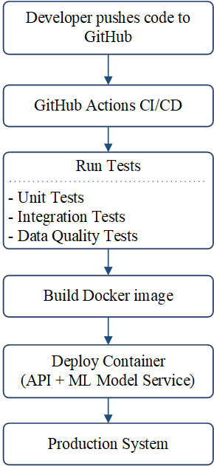
Figure 3: CI/CD pipeline

Detailed CI/CD Steps
- Code push
  - Developers push code changes to the repository.
  - This triggers the CI/CD pipeline automatically.
- Run tests
  - Executes all test suites:
    - Unit tests
    - Integration tests
    - Data quality tests
  - If any test fails, the pipeline stops.
- Build docker image
  - The application and model are packaged into a Docker container.
  - Ensures consistency across environments.
- Deployment
  - The container is deployed to the target environment.
  - The updated API service becomes available.

RESPONSIBLE AI
The proposed system integrates Responsible AI principles to ensure that the machine learning model is fair, transparent, privacy-preserving, and ethically sound. Given that the system predicts customer satisfaction and trust toward AI technologies, it is critical to ensure that the model does not introduce bias or negatively impact user trust.

Fairness Analysis and Bias Detection
Ensuring fairness is a key requirement for the system, especially since the dataset includes demographic and behavioral attributes such as age, gender, and shopping patterns.
The model is evaluated for potential bias across different user groups by comparing performance metrics such as accuracy, precision, recall, and F1-score across demographic segments (e.g., age groups, gender). This helps identify whether the model systematically performs better or worse for certain groups.
In addition, fairness metrics such as:
- Demographic parity (ensuring similar prediction distribution across groups)
- Equal opportunity (ensuring equal true positive rates across groups)
are considered to detect potential bias.
If bias is detected, mitigation strategies may include:
- Feature selection adjustments (removing sensitive attributes if necessary)
- Rebalancing training data
- Applying fairness-aware learning techniques
These steps ensure that the model provides equitable predictions and does not disadvantage any specific group of users.

Model Explainability
To improve transparency and trust in the system, model explainability techniques are applied.
The system uses SHAP (SHapley Additive exPlanations) to interpret model predictions by quantifying the contribution of each feature to the final output. SHAP enables both:
- Local explanations: explaining individual predictions (e.g., why a specific user is predicted to have high satisfaction)
- Global explanations: identifying the most important features influencing the model
For example, the model may reveal that:
- Trust in AI and AI usage frequency positively influence satisfaction predictions
- Privacy concerns negatively impact predicted satisfaction
SHAP summary plots and feature importance visualizations are used to provide insights into model behavior.
These explanations improve transparency, support debugging, and help stakeholders better understand the decision-making process of the model.

Data privacy considerations
Protecting user data is a critical requirement in the system design.
The system applies several data privacy measures:
- Data anonymization: Personally identifiable information (PII) is removed or masked before processing
- Data minimization: Only necessary features are collected and used for modeling
- Aggregation techniques: Behavioral patterns are analyzed at an aggregated level instead of tracking individual identities
In addition, secure data handling practices are implemented to ensure that sensitive user information is not exposed during data processing or model deployment.
These measures ensure compliance with privacy principles while still enabling effective machine learning modeling.

Ethical implications
The system also considers broader ethical implications of deploying AI in customer experience analysis.
Potential risks include:
- Bias in predictions, which may lead to unfair treatment of certain user groups
- Over-reliance on AI systems, where businesses depend too heavily on automated predictions without human validation
- Misinterpretation of predictions, which may negatively affect customer experience if decisions are based solely on model outputs
To address these concerns, the system adopts a human-in-the-loop approach, where:
- Automated predictions support decision-making
- Critical decisions (e.g., business strategies) involve human review
Additionally, transparency is emphasized by providing explainable outputs (via SHAP), allowing stakeholders to understand and validate model behavior.
By considering these ethical aspects, the system ensures responsible deployment of AI technologies while maintaining user trust.

DOCUMENTATION

README
The project provides a comprehensive README file that contains detailed instructions for setting up, running, and testing the system. The README is available at the following link:
https://github.com/LamNguyen181198/DDM501_Final_Project_Repository/blob/main/README.md
The README document includes step-by-step guidance to help users and developers understand and operate the system effectively. The main sections are as follows:
- Repository Structure
Describes the organization of the project, including directories for source code, data, pipelines, artifacts, and tests.
- Prerequisites
Lists the required tools and dependencies, such as Python environment, Docker, and necessary libraries.
- Local Setup
Provides instructions for setting up the development environment and installing dependencies.
- Dataset Requirement
Explains how to obtain and prepare the dataset (manual placement or automatic download from Kaggle).
- Run MLflow Locally
Guides users on how to start the MLflow tracking server for experiment tracking.
- Train the Model
Describes how to execute the training pipeline, including data ingestion, preprocessing, model training, and artifact generation.
- Run the API Locally
Explains how to start the API service and access available endpoints for prediction and monitoring.
- Run Tests
Provides instructions to execute the test suite to validate system functionality.
- Run with Docker Compose
Describes how to deploy the full system (API, MLflow, monitoring tools) using Docker Compose.
- Current Limitation
Highlights known limitations of the system, such as dataset constraints, model generalization, or infrastructure limitations.
The README serves as a central reference for both developers and users, ensuring reproducibility, ease of deployment, and efficient system operation.

API Documentation
FastAPI automatically generates Swagger documentation at:
/docs

CONCLUSION
This project demonstrates a complete ML-enabled system that predicts customer satisfaction toward AI systems in online shopping environments.
The system integrates multiple concepts from DevOps, DataOps, and MLOps, including:
- Reproducible ML pipelines
- Containerized deployment
- System monitoring
- CI/CD automation
The project highlights how machine learning models can be integrated into production-ready systems to generate business insights.

REFERENCES
[1] W. Team, “Ai In The Ecommerce Industry Statistics: Reports 2025,” WifiTalents. Accessed: Dec. 29, 2025. [Online]. Available: https://wifitalents.com/ai-in-the-ecommerce-industry-statistics/
[2] “AI in eCommerce Statistics: Trends and insights for 2025.” Accessed: Dec. 29, 2025. [Online]. Available: https://www.clickpost.ai/blog/ai-in-ecommerce-statistics
[3] “AI in Ecommerce and Retail: Trends, Use Cases, and Business Impact - Kyanon Digital.” Accessed: Dec. 29, 2025. [Online]. Available: https://kyanon.digital/blog/ai-solutions-in-ecommerce-retail/
[4] W. Team, “Ai In The Ecommerce Industry Statistics: Reports 2025,” WifiTalents. Accessed: Dec. 29, 2025. [Online]. Available: https://wifitalents.com/ai-in-the-ecommerce-industry-statistics/
[5] W. Team, “Ai In The Ecommerce Industry Statistics: Reports 2025,” WifiTalents. Accessed: Dec. 29, 2025. [Online]. Available: https://wifitalents.com/ai-in-the-ecommerce-industry-statistics/
[6] “AI in eCommerce Statistics: Trends and insights for 2025.” Accessed: Dec. 29, 2025. [Online]. Available: https://www.clickpost.ai/blog/ai-in-ecommerce-statistics
[7] “AI in eCommerce Statistics: Trends and insights for 2025.” Accessed: Dec. 29, 2025. [Online]. Available: https://www.clickpost.ai/blog/ai-in-ecommerce-statistics
[8] W. Team, “Ai In The Ecommerce Industry Statistics: Reports 2025,” WifiTalents. Accessed: Dec. 29, 2025. [Online]. Available: https://wifitalents.com/ai-in-the-ecommerce-industry-statistics/
[9] “AI-influenced shopping boosts online holiday sales, Salesforce data shows | Reuters.” Accessed: Dec. 29, 2025. [Online]. Available: https://www.reuters.com/business/retail-consumer/ai-influenced-shopping-boosts-online-holiday-sales-salesforce-data-shows-2025-01-06/
[10] “Black Friday online spending surges as Americans embrace AI to assist with shopping | New York Post.” Accessed: Dec. 29, 2025. [Online]. Available: https://nypost.com/2025/11/30/business/black-friday-online-spending-surges-as-americans-embrace-ai-to-assist-with-shopping/
[11] E. Kim, “Morgan Stanley: Nearly half of online shoppers will use AI agents by 2030, adding $115 billion to US e-commerce,” Business Insider. Accessed: Dec. 29, 2025. [Online]. Available: https://www.businessinsider.com/morgan-stanley-expects-ai-agents-to-fuel-e-commerce-boom-2025-11
[12] “AI in E-commerce Statistics: Top Trends & Key Applications.” Accessed: Dec. 29, 2025. [Online]. Available: https://www.allaboutai.com/resources/ai-in-e-commerce-statistics
[13] W. Team, “Ai In The Ecommerce Industry Statistics: Reports 2025,” WifiTalents. Accessed: Dec. 29, 2025. [Online]. Available: https://wifitalents.com/ai-in-the-ecommerce-industry-statistics/
[14] “AI in eCommerce Statistics: Trends and insights for 2025.” Accessed: Dec. 29, 2025. [Online]. Available: https://www.clickpost.ai/blog/ai-in-ecommerce-statistics
[15] “AI in eCommerce Statistics: Trends and insights for 2025.” Accessed: Dec. 29, 2025. [Online]. Available: https://www.clickpost.ai/blog/ai-in-ecommerce-statistics
[16] “AI in Customer Service & Chatbots: Insights & Findings,” Studocu. Accessed: Mar. 08, 2026. [Online]. Available: https://www.studocu.vn/vn/document/dai-hoc-kinh-te-quoc-dan/thuong-mai-dien-tu/ai-in-customer-service-chatbots-insights-findings/142501084
[17] K. Marcineková, A. J. Sujová, and R. Ďurica, “Implementing AI Chatbots in Customer Service Optimization—A Case Study in Micro-Enterprise,” Information, vol. 16, no. 12, p. 1078, Dec. 2025, doi: 10.3390/info16121078.
[18] “Key Statistics on AI in Customer Service.” Accessed: Mar. 08, 2026. [Online]. Available: https://genuitysystems.com/blog/key-statistics-on-ai-in-customer-service
[19] “AI Customer Service for E-Commerce | Boost CSAT by 30%.” Accessed: Mar. 08, 2026. [Online]. Available: https://agentiveaiq.com/blog/ai-rules-for-e-commerce-smarter-customer-service-now

